Propositional logic in Artificial intelligence

Propositional logic (PL) is the simplest form of logic where all the statements are made by propositions. A proposition is a declarative statement which is either true or false. It is a technique of knowledge representation in logical and mathematical form.

Example:

1. a) It is Sunday.
2. b) The Sun rises from West (False proposition)
3. c) 3+3= 7(False proposition)
4. d) 5 is a prime number.

**Following are some basic facts about propositional logic:**

* Propositional logic is also called Boolean logic as it works on 0 and 1.
* In propositional logic, we use symbolic variables to represent the logic, and we can use any symbol for a representing a proposition, such A, B, C, P, Q, R, etc.
* Propositions can be either true or false, but it cannot be both.
* Propositional logic consists of an object, relations or function, and **logical connectives**.
* These connectives are also called logical operators.
* The propositions and connectives are the basic elements of the propositional logic.
* Connectives can be said as a logical operator which connects two sentences.
* A proposition formula which is always true is called **tautology**, and it is also called a valid sentence.
* A proposition formula which is always false is called **Contradiction**.
* A proposition formula which has both true and false values is called
* Statements which are questions, commands, or opinions are not propositions such as "**Where is Rohini**", "**How are you**", "**What is your name**", are not propositions.

Syntax of propositional logic:

The syntax of propositional logic defines the allowable sentences for the knowledge representation. There are two types of Propositions:

1. **Atomic Propositions**
2. **Compound propositions**

* **Atomic Proposition:** Atomic propositions are the simple propositions. It consists of a single proposition symbol. These are the sentences which must be either true or false.

**Example:**

1. a) 2+2 is 4, it is an atomic proposition as it is a **true** fact.
2. b) "The Sun is cold" is also a proposition as it is a **false** fact.

* **Compound proposition:** Compound propositions are constructed by combining simpler or atomic propositions, using parenthesis and logical connectives.

**Example:**

1. a) "It is raining today, and street is wet."
2. b) "Ankit is a doctor, and his clinic is in Mumbai."

Logical Connectives:

Logical connectives are used to connect two simpler propositions or representing a sentence logically. We can create compound propositions with the help of logical connectives. There are mainly five connectives, which are given as follows:

1. **Negation:** A sentence such as ¬ P is called negation of P. A literal can be either Positive literal or negative literal.
2. **Conjunction:** A sentence which has **∧**connective such as, **P ∧ Q** is called a conjunction.  
   **Example:** Rohan is intelligent and hardworking. It can be written as,  
   **P= Rohan is intelligent**,  
   **Q= Rohan is hardworking. → P∧ Q**.
3. **Disjunction:** A sentence which has ∨ connective, such as **P ∨ Q**. is called disjunction, where P and Q are the propositions.  
   **Example: "Ritika is a doctor or Engineer"**,  
   Here P= Ritika is Doctor. Q= Ritika is Doctor, so we can write it as **P ∨ Q**.
4. **Implication:** A sentence such as P → Q, is called an implication. Implications are also known as if-then rules. It can be represented as  
               **If** it is raining, then the street is wet.  
           Let P= It is raining, and Q= Street is wet, so it is represented as P → Q
5. **Biconditional:** A sentence such as **P⇔ Q is a Biconditional sentence, example If I am breathing, then I am alive**  
               P= I am breathing, Q= I am alive, it can be represented as P ⇔ Q.

Following is the summarized table for Propositional Logic Connectives:

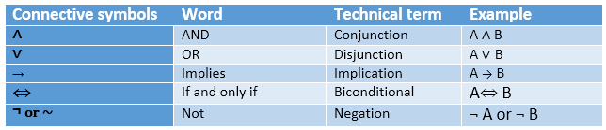

Truth Table:

In propositional logic, we need to know the truth values of propositions in all possible scenarios. We can combine all the possible combination with logical connectives, and the representation of these combinations in a tabular format is called **Truth table**. Following are the truth table for all logical connectives:

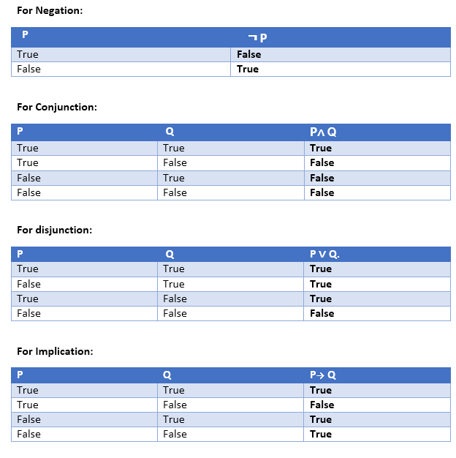 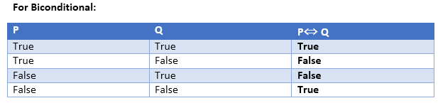

Truth table with three propositions:

We can build a proposition composing three propositions P, Q, and R. This truth table is made-up of 8n Tuples as we have taken three proposition symbols.

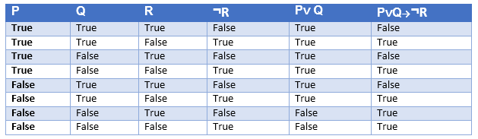

Precedence of connectives:

Just like arithmetic operators, there is a precedence order for propositional connectors or logical operators. This order should be followed while evaluating a propositional problem. Following is the list of the precedence order for operators:

|  |  |
| --- | --- |
| **Precedence** | **Operators** |
| First Precedence | Parenthesis |
| Second Precedence | Negation |
| Third Precedence | Conjunction(AND) |
| Fourth Precedence | Disjunction(OR) |
| Fifth Precedence | Implication |
| Six Precedence | Biconditional |

Note: For better understanding use parenthesis to make sure of the correct interpretations. Such as ¬R∨ Q, It can be interpreted as (¬R) ∨ Q.

Logical equivalence:

Logical equivalence is one of the features of propositional logic. Two propositions are said to be logically equivalent if and only if the columns in the truth table are identical to each other.

Let's take two propositions A and B, so for logical equivalence, we can write it as A⇔B. In below truth table we can see that column for ¬A∨ B and A→B, are identical hence A is Equivalent to B

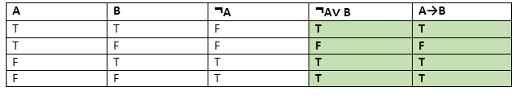

Properties of Operators:

* **Commutativity:**
  + P∧ Q= Q ∧ P, or
  + P ∨ Q = Q ∨ P.
* **Associativity:**
  + (P ∧ Q) ∧ R= P ∧ (Q ∧ R),
  + (P ∨ Q) ∨ R= P ∨ (Q ∨ R)
* **Identity element:**
  + P ∧ True = P,
  + P ∨ True= True.
* **Distributive:**
  + P∧ (Q ∨ R) = (P ∧ Q) ∨ (P ∧ R).
  + P ∨ (Q ∧ R) = (P ∨ Q) ∧ (P ∨ R).
* **DE Morgan's Law:**
  + ¬ (P ∧ Q) = (¬P) ∨ (¬Q)
  + ¬ (P ∨ Q) = (¬ P) ∧ (¬Q).
* **Double-negation elimination:**
  + ¬ (¬P) = P.

Limitations of Propositional logic:

* We cannot represent relations like ALL, some, or none with propositional logic. Example:
  1. **All the girls are intelligent.**
  2. **Some apples are sweet.**
* Propositional logic has limited expressive power.
* In propositional logic, we cannot describe statements in terms of their properties or logical relationships.

First-Order Logic in Artificial intelligence

In the topic of Propositional logic, we have seen that how to represent statements using propositional logic. But unfortunately, in propositional logic, we can only represent the facts, which are either true or false. PL is not sufficient to represent the complex sentences or natural language statements. The propositional logic has very limited expressive power. Consider the following sentence, which we cannot represent using PL logic.

* **"Some humans are intelligent", or**
* **"Sachin likes cricket."**

To represent the above statements, PL logic is not sufficient, so we required some more powerful logic, such as first-order logic.

First-Order logic:

* First-order logic is another way of knowledge representation in artificial intelligence. It is an extension to propositional logic.
* FOL is sufficiently expressive to represent the natural language statements in a concise way.
* First-order logic is also known as **Predicate logic or First-order predicate logic**. First-order logic is a powerful language that develops information about the objects in a more easy way and can also express the relationship between those objects.
* First-order logic (like natural language) does not only assume that the world contains facts like propositional logic but also assumes the following things in the world:
  + **Objects:** A, B, people, numbers, colors, wars, theories, squares, pits, wumpus, ......
  + **Relations:** **It can be unary relation such as:** red, round, is adjacent, **or n-any relation such as:** the sister of, brother of, has color, comes between
  + **Function:** Father of, best friend, third inning of, end of, ......
* As a natural language, first-order logic also has two main parts:
  + **Syntax**
  + **Semantics**

Syntax of First-Order logic:

The syntax of FOL determines which collection of symbols is a logical expression in first-order logic. The basic syntactic elements of first-order logic are symbols. We write statements in short-hand notation in FOL.

Basic Elements of First-order logic:

Following are the basic elements of FOL syntax:

|  |  |
| --- | --- |
| **Constant** | 1, 2, A, John, Mumbai, cat,.... |
| **Variables** | x, y, z, a, b,.... |
| **Predicates** | Brother, Father, >,.... |
| **Function** | sqrt, LeftLegOf, .... |
| **Connectives** | ∧, ∨, ¬, ⇒, ⇔ |
| **Equality** | == |
| **Quantifier** | ∀, ∃ |

Atomic sentences:

* Atomic sentences are the most basic sentences of first-order logic. These sentences are formed from a predicate symbol followed by a parenthesis with a sequence of terms.
* We can represent atomic sentences as **Predicate (term1, term2, ......, term n)**.

**Example: Ravi and Ajay are brothers: => Brothers(Ravi, Ajay).  
                Chinky is a cat: => cat (Chinky)**.

Complex Sentences:

* Complex sentences are made by combining atomic sentences using connectives.

**First-order logic statements can be divided into two parts:**

* **Subject:** Subject is the main part of the statement.
* **Predicate:** A predicate can be defined as a relation, which binds two atoms together in a statement.

**Consider the statement: "x is an integer."**, it consists of two parts, the first part x is the subject of the statement and second part "is an integer," is known as a predicate.

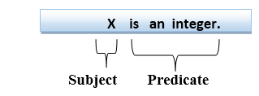

Quantifiers in First-order logic:

* A quantifier is a language element which generates quantification, and quantification specifies the quantity of specimen in the universe of discourse.
* These are the symbols that permit to determine or identify the range and scope of the variable in the logical expression. There are two types of quantifier:
  1. **Universal Quantifier, (for all, everyone, everything)**
  2. **Existential quantifier, (for some, at least one).**

Universal Quantifier:

Universal quantifier is a symbol of logical representation, which specifies that the statement within its range is true for everything or every instance of a particular thing.

The Universal quantifier is represented by a symbol ∀, which resembles an inverted A.

*Note: In universal quantifier we use implication "→".*

If x is a variable, then ∀x is read as:

* **For all x**
* **For each x**
* **For every x.**

Example:

**All man drink coffee.**

Let a variable x which refers to a cat so all x can be represented in UOD as below:

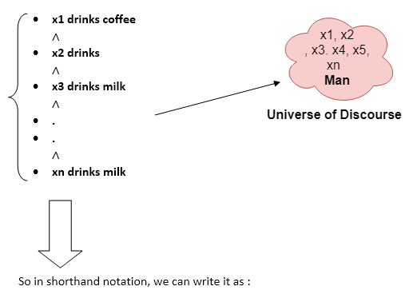

**∀x man(x) → drink (x, coffee).**

It will be read as: There are all x where x is a man who drink coffee.

Existential Quantifier:

Existential quantifiers are the type of quantifiers, which express that the statement within its scope is true for at least one instance of something.

It is denoted by the logical operator ∃, which resembles as inverted E. When it is used with a predicate variable then it is called as an existential quantifier.

*Note: In Existential quantifier we always use AND or Conjunction symbol (∧).*

If x is a variable, then existential quantifier will be ∃x or ∃(x). And it will be read as:

* **There exists a 'x.'**
* **For some 'x.'**
* **For at least one 'x.'**

Example:

**Some boys are intelligent.**

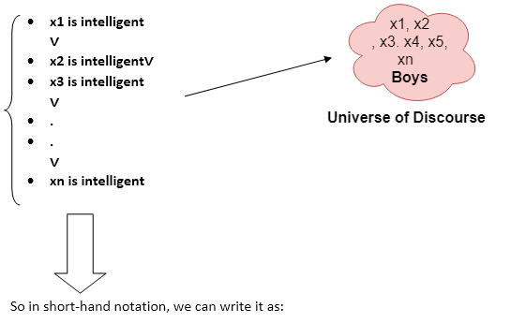

**∃x: boys(x) ∧ intelligent(x)**

It will be read as: There are some x where x is a boy who is intelligent.

Points to remember:

* The main connective for universal quantifier **∀** is implication **→**.
* The main connective for existential quantifier **∃** is and **∧**.

Properties of Quantifiers:

* In universal quantifier, ∀x∀y is similar to ∀y∀x.
* In Existential quantifier, ∃x∃y is similar to ∃y∃x.
* ∃x∀y is not similar to ∀y∃x.

Some Examples of FOL using quantifier:

**1. All birds fly.**  
In this question the predicate is "**fly(bird)**."  
And since there are all birds who fly so it will be represented as follows.  
              **∀x bird(x) →fly(x)**.

**2. Every man respects his parent.**  
In this question, the predicate is "**respect(x, y)," where x=man, and y= parent**.  
Since there is every man so will use ∀, and it will be represented as follows:  
              **∀x man(x) → respects (x, parent)**.

**3. Some boys play cricket.**  
In this question, the predicate is "**play(x, y)**," where x= boys, and y= game. Since there are some boys so we will use **∃, and it will be represented as**:  
              **∃x boys(x) → play(x, cricket)**.

**4. Not all students like both Mathematics and Science.**  
In this question, the predicate is "**like(x, y)," where x= student, and y= subject**.  
Since there are not all students, so we will use **∀ with negation, so** following representation for this:  
              **¬∀ (x) [ student(x) → like(x, Mathematics) ∧ like(x, Science)].**

**5. Only one student failed in Mathematics.**  
In this question, the predicate is "**failed(x, y)," where x= student, and y= subject**.  
Since there is only one student who failed in Mathematics, so we will use following representation for this:  
              **∃(x) [ student(x) → failed (x, Mathematics) ∧∀ (y) [¬(x==y) ∧ student(y) → ¬failed (x, Mathematics)]**.

Free and Bound Variables:

The quantifiers interact with variables which appear in a suitable way. There are two types of variables in First-order logic which are given below:

**Free Variable:** A variable is said to be a free variable in a formula if it occurs outside the scope of the quantifier.

**Example: ∀x ∃(y)[P (x, y, z)], where z is a free variable.**

**Bound Variable:** A variable is said to be a bound variable in a formula if it occurs within the scope of the quantifier.

**Example: ∀x [A (x) B( y)], here x and y are the bound variables.**